
COMPUTING

Purpose of Study:
A high-quality computing education equips pupils to use computational thinking and creativity to understand and change the world. Computing has deep links with mathematics, science, and design and technology, and provides insights into both natural and artificial systems. The core of computing is computer science, in which pupils are taught the principles of information and computation, how digital systems work, and how to put this knowledge to use through programming. Building on this knowledge and understanding, pupils are equipped to use information technology to create programs, systems and a range of content. Computing also ensures that pupils become digitally literate – able to use, and express themselves and develop their ideas through, information and communication technology – at a level suitable for the future workplace and as active participants in a digital world.

The national curriculum for computing aims to ensure that all pupils:
- can understand and apply the fundamental principles and concepts of computer science, including abstraction, logic, algorithms and data representation

- can analyse problems in computational terms, and have repeated practical experience of writing computer programs in order to solve such problems

- can evaluate and apply information technology, including new or unfamiliar technologies, analytically to solve problems are responsible, competent, confident and creative users of information and communication technology.

KS1 Pupils should be taught:
- understand what algorithms are; how they are implemented as programs on digital devices; and that programs execute by

- following precise and unambiguous instructions

- create and debug simple programs

- use logical reasoning to predict the behaviour of simple programs

- use technology purposefully to create, organise, store, manipulate and retrieve digital content

- recognise common uses of information technology beyond school

- use technology safely and respectfully, keeping personal information private; identify where to go for help and support when they have concerns about content or contact on the internet or other online technologies
EYFS:

We recognise that Computing is no longer included as a separate strand in the Early Years Framework, however we believe that children are exposed to a variety of digital systems and resources through their daily lives and therefore want to support them to become conscientious and confident users of technology. We also ensure that all children know how to protect themselves and stay safe in a digital world.
Intent
Across the Dunchurch Federation, we aim to prepare our learners for their future by giving them the opportunities to gain knowledge and develop skills that will equip them for an ever-changing digital world. Knowledge and understanding of ICT is of increasing importance for children’s future both at home and for employment. Our Computing curriculum focuses on a progression of skills in digital literacy, computer science, information technology and online safety to ensure that children become competent in safely using, as well as understanding, technology. These strands are revisited repeatedly through a range of themes during children’s time in school to ensure the learning is embedded and skills are successfully developed. Our intention is that Computing also supports children’s creativity and cross curricular learning to engage children and enrich their experiences in school.

Implementation
Our whole curriculum is shaped by our school vision which aims to enable all children, regardless of background, ability, additional needs, to flourish to become the very best version of themselves they can possibly be. We teach the National Curriculum in KS1 through Purple Mash supported by a clear skills and knowledge progression. This ensures that skills and knowledge are built on year by year and sequenced appropriately to maximise learning for all children.
To ensure a broad range of skills and understanding, Computing is taught across 3 main strands: digital literacy, computer science and information technology. As part of information technology, children learn to use and express themselves and develop their ideas through ICT for example writing and presenting as well as exploring art and design using multimedia. Within digital literacy, children develop practical skills in the safe use of ICT and the ability to apply these skills to solving relevant, worthwhile problems for example understanding safe use of the internet. In computer science we teach children to understand and apply the fundamental principles and concepts of computer science, including abstraction, logic, algorithms and data representation. We also ensure that we teach a progressive sequence of Computing vocabulary to support children in their understanding. At Dunchurch, we give children access to a wide range of good quality resources and provide cross-curricular opportunities for children to apply their Computing knowledge and skills. Online safety is taught as a stand alone lesson most terms and where not taught it is recapped throughout the computing teaching, as well as referred to throughout the learning wherever relevant. Online safety procedures are communicated with all staff and parents.

Impact
The implementation of this curriculum ensures that when children leave the Dunchurch Federation they are competent and safe users of ICT with an understanding of how technology works. They will have developed skills to express themselves and be creative in using digital media and be equipped to apply their skills in Computing to different challenges going forward.


Skills and Knowledge

 | Rising 3’s | Pre-school | Reception | Y1 | Y2
Information technology | Accesses touch screen technology and other technological devices in continuous provision, beginning to understand that they should be handled with care.  Begin to use technology in role play for a purpose e.g. imitating using a mobile phone/tablet.  Can operate simple equipment such as a talking tin lid or recordable microphone.  Experiments with touchscreen technology, making marks. | Handles touchscreen technology and other technological devices in continuous provision with care.  Continue to use technology in role play for a purpose e.g. imitating using a mobile phone/tablet.  Continues to operate a range of simple technological equipment such as torches, CD players, story phones and simple electronic toys.  Assigns meaning to marks that they make using touch screen technology. | Handles touchscreen technology and other technological devices with care and growing competence  Uses technology appropriately through role play e.g. using the electronic pads to make a shopping list, taking a photo or using the recordable microphones when acting in role on the stage.  Understand that technology can be used for a range of different purposes at both home and school.  Understand that work created on devices can be printed, and print work assisted by an adult.  To access and use simple activities using touch technology with increasing control.  Uses touch screen technology to draw, write and paint. | Use a mouse / trackpad / touch screen to move the cursor around and select items.  Start and shut down a computer or electronic device, although some prompts may be needed.  Type name using a keyboard.  Type simple sentences using a keyboard.  To enter information into a template to create a pictogram.  Use a paint program to create a piece of art or a picture for a purpose, making use of different sized brushes and paint effects.  With the support of an adult, save and retrieve items of work into the correct class folder.  Send work to print with the support of an adult.  Recognise common uses of technology, both within and beyond school. | Start and shut down a computer or electronic device.  Type name, starting with a capital letter, using a keyboard.  Type simple sentences using a keyboard, using the correct punctuation for Year 2.  Create different graphs using digital technology.  Use a paint program to create a piece of art or a picture for a purpose, making use of different sized brushes and paint effects with increasing control. Send work to print independently.  Save and retrieve items of work into the correct class folder.  Recognise many common uses of technology, both within and beyond school. State how they are useful for their particular purpose.

 | Rising 3’s | Pre-school | Reception | Y1 | Y2
Computer Science and Digital Literacy | Use toys such as remote control cars in continuous provision to begin to experiment with programming toys. | Continue to use toys such as remote control cars in continuous provision to begin to experiment with programming toys. | Explore BeeBots, pressing buttons to move forwards, backwards and side to side.  Use the materials in continuous provision to build a course for BeeBots and start to attempt to program it to move around the course. | To continue to explore BeeBots, combining sequences of instructions to follow a pattern or create a shape.  To begin to develop computational thinking by following instructions given to move around a course using Beebots and other computer programs (linked to maths positional language – see maths grid).  Create a series of instructions for others to follow using Beebots or online programs (linked to maths positional language – see maths grid).  Using programmable construction kits, follow a series of instructions to program a moving object with the support of an adult.  Using programmable construction kits, create a series of instructions to program a moving object with the support of an adult.  Using Scratch Jnr, design own character, follow a series of instructions to create a moving object and create own algorithms with the support of an adult.  Using programs throughout the unit of work, begin to predict what might happen if the algorithm is altered and test this with the support of an adult.  To understand that computers and technology can be used to represent and model situations using algorithms.  To begin to understand that programs need precise and unambiguous instructions.  To understand that algorithms can go wrong and can be debugged.  Formulate clear instructions for both paper and technological exercises, beginning to understand that they need to be precise and unambiguous. Test these out and start to understand that debugging may be necessary. | Explain what an algorithm is.  To understand that programs need precise and unambiguous instructions.  Formulate clear instructions for both paper and technological exercises, understanding they need to be precise and unambiguous. Test these out and debug as necessary.  Combine sequences of instructions to follow a pattern or create a shape using a Blue Bot and laptop / iPad, debugging when mistakes  Develop computational thinking by following instructions given to move around a course using Blue Bots and other computer programs, debugging when mistakes have been made.  Create a series of instructions for others to follow using Blue Bots or online programs (linked to maths positional language – see maths grid).  Using programmable construction kits, follow a series of instructions to program a moving object.  Using programmable construction kits, create a series of instructions to program a moving object.  Using Scratch Jnr, design own character, follow a series of instructions to create a moving object and create own algorithms.  Using programs throughout the unit of work, what might happen if the algorithm is altered, and then test this.

 | Rising 3’s | Pre-school | Reception | Y1 | Y2
Online Safety | Participate in discussions with an adult to begin to understand that there is some information about you like your name and address that you should never share with others.  Adults to discuss with children that if they find inappropriate content on a device, or something that makes them feel worried, they should immediately tell an adult.  Participate in discussions regarding being kind to each other when using devices. | Start to understand that there is some information about you like your name and address that you should never share with others.  Adults to discuss with children that if they find inappropriate content on a device, or something that makes them feel worried, they should immediately tell an adult.  Participate in discussions regarding being kind to each other when using devices. | Understand that there is some information about you like your name and address that you should never share with others.  Knows that the internet can be used to find things out and participate in finding out answers to questions within an adult guided group.  Adults to discuss with children that if they find inappropriate content on a device, or something that makes them feel worried, they should immediately tell an adult.  Begin to understand that bullying can take place over digital devices which is called cyberbullying, and it must never be tolerated. | Understand that personal information should be kept private, including passwords.  Understand that not everything found on the internet is true.  Compose an email as a class and discuss the need to be kind.  Begin to understand that not everything found on the internet is safe and begin to understand that you should not open anything in a message or email sent from an unknown user.  Begin to understand that there are unknown people on the internet and this impacts the way that devices should be used.  Understand that if an unknown person contacts them on a device they should speak to an adult straight away.  Know that if they find anything inappropriate when using a device they should immediately tell an adult and minimise the screen if this is possible.  Begin to understand that bullying behaviour can take place over devices and this is termed cyberbullying, and understand that cyberbullying must never be tolerated. | Continue to understand that personal information should be kept private, including passwords.  Begin to apply knowledge that not everything found on the internet is true by evaluating spoof websites provided by the teacher.  Understand that you should be as kind in emails / messages sent as you should be when talking to someone face to face.  Understand that not everything found on the internet is safe and understand that you should not open anything in a message or email sent from an unknown user.  Understand that there are unknown people on in the internet and sometimes people can pretend to be someone else. Understand that this impacts the way that devices should be used.  Understand that if an unknown person contacts them on a device they should speak to an adult straight away.  Know that if they find anything inappropriate when using a device they should immediately tell an adult and minimise the screen if this is possible.  Understand that bullying behaviour can take place over devices and this is termed cyberbullying, and understand that cyberbullying must never be tolerated.

Purple Mash progression of skills: KS1 only

Computer Science:
 | Y1 | Y2
National Curriculum Statement:
- Understand what algorithms are; how they are implemented as programs on digital devices; and that programs execute by following precise and unambiguous instructions.
- Create and debug simple programs.
- Use logical reasoning to predict the behaviour of simple programs.
Computer Science: Algorithms | - Children understand that an algorithm is a set of instructions used to solve a problem or achieve an objective. They know that a computer program turns an algorithm into code that the computer can understand.  - Children can work out what is wrong with a simple  algorithm when the steps are out of order, e.g. The Wrong Sandwich in Purple Mash and can write their own simple algorithm, e.g. Colouring in a Bird activity. Children know that an unexpected outcome is due to the code they have created and can make logical attempts to fix the code , e.g. Bubbles activity in 2Code.  - When looking at a program, children can read code one line at a time and make good attempts to envision the bigger picture of the overall effect of the program.  - Children can, for example, interpret where the turtle in 2Go challenges will end up at the end of the program. | - Children can explain that an algorithm is a set of instructions to complete a task. When designing simple programs, children show an awareness of the need to be precise with their algorithms so that they can be successfully converted into code.  - Children can create a simple program that achieves a specific purpose. They can also identify and correct some errors, e.g. Debug Challenges: Chimp. Children’s program designs display a growing awareness of the need for logical, programmable steps.  - Children can identify the parts of a program that  respond to specific events and initiate specific actions. For example, they can write a cause and effect sentence of what will happen in a program.

Information Technology:
 | Y1 | Y2
National Curriculum Statement:
- Use technology purposefully to create, organise, store, manipulate and retrieve digital content.
Using technology | - Children are able to sort, collate, edit and store simple digital content e.g. children can name, save and retrieve their work and follow simple instructions to access online resources, use Purple Mash 2Quiz example (sorting shapes), 2Code design mode (manipulating backgrounds) or using pictogram software such as 2Count. | - Children demonstrate an ability to organise data using, for example, a database such as 2Investigate and can retrieve specific data for conducting simple searches. Children are able to edit more complex digital data such as music compositions within 2Sequence. Children are confident when creating, naming, saving and retrieving content. Children use a range of media in their digital content including photos, text and sound

Digital Literacy:
 | Y1 | Y2
National Curriculum Statement:
- Recognise common uses of information technology beyond school.
- Use technology safely and respectfully, keeping personal information private; identify where to go for help and support when they have concerns about content or contact on the internet or other online technologies.
Digital literacy | - Children understand what is meant by technology and can identify a variety of examples both in and out of school. They can make a distinction between objects that use modern technology and those that do not e.g. a microwave vs. a chair  - Children understand the importance of keeping information, such as their usernames and passwords, private and actively demonstrate this in lessons. Children take ownership of their work and save this in their own private space such as their My Work folder on Purple Mash. | - Children can effectively retrieve relevant, purposeful digital content using a search engine. They can apply their learning of effective searching beyond the classroom. They can share this knowledge, e.g. 2Publish example template. Children make links between technology they see around them, coding and multimedia work they do in school e.g. animations, interactive code and programs.  - Children know the implications of inappropriate online searches. Children begin to understand how things are shared electronically such as posting work to the Purple Mash display board. They develop an understanding of using email safely by using 2Respond activities on Purple Mash and know ways of reporting inappropriate behaviours and content to a trusted adult
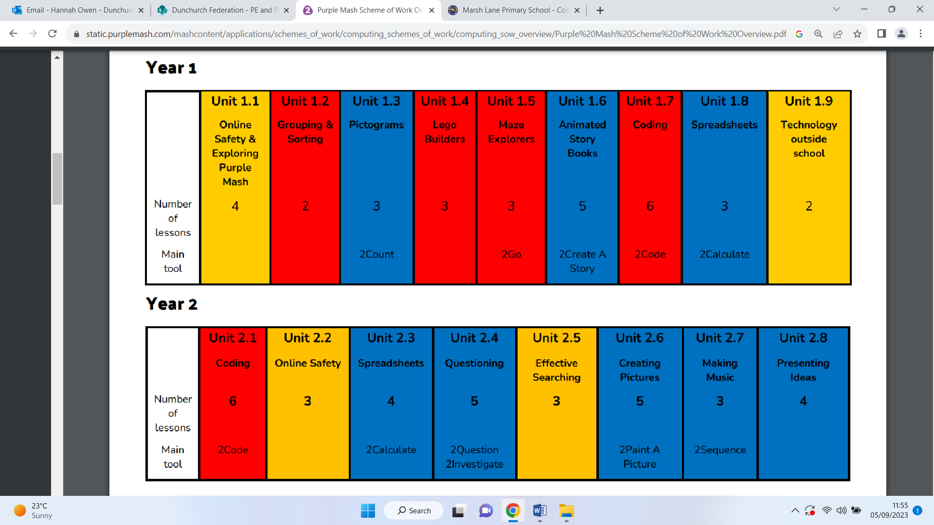

Unit summary:

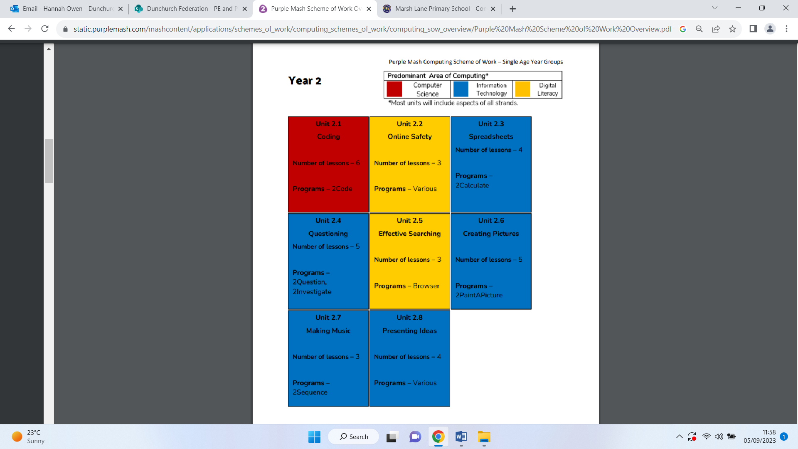
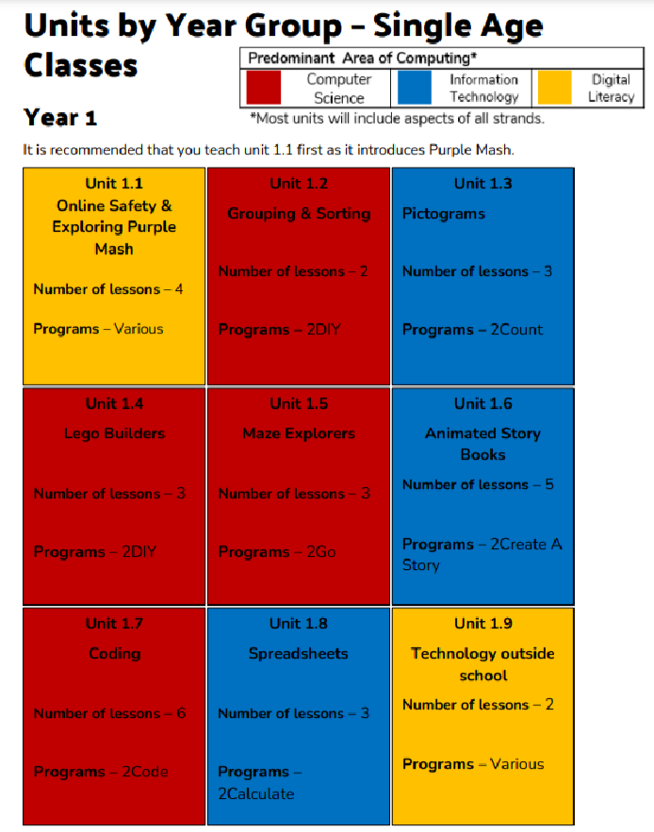
Units by year group:
Year 1: Year 2:

