RE – Who is Special and Why?
Prior Learning |  | Concepts
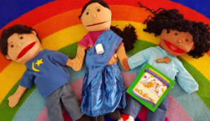  Knowing that people have different ideas.  The word God is a name.  I know people celebrate special times. |  | Belonging – Things in their right place, or a feeling of welcome.
 |  | Belief – That some people have beliefs about God or special stories.
Key Vocabulary |  | Images, icons and maps.
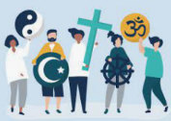  Religion | A set of beliefs that are important to a group of people. | 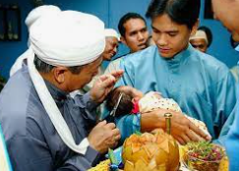  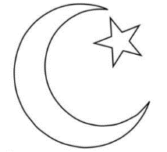  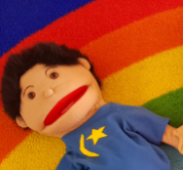  The prophet Mohammed  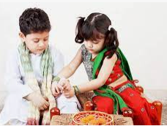  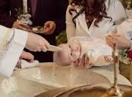  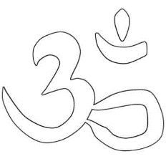  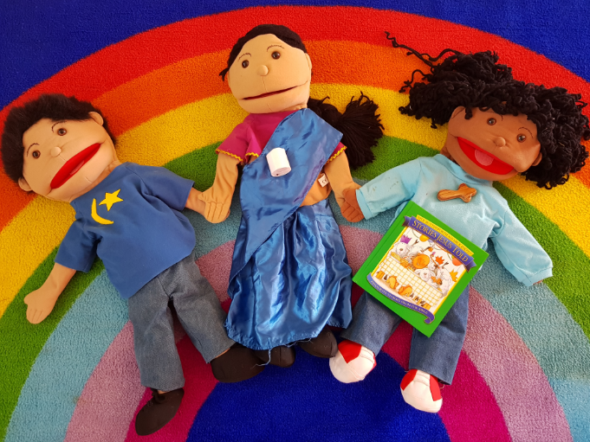  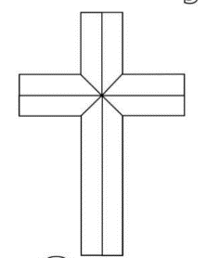  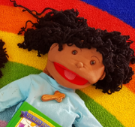  Jesus  Raksha Bandhan
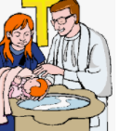  Ceremony | Important and traditional activities on a special or sacred occasion.
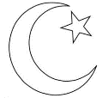  Muslim | Muslims believe in one God (Allah) and show welcome to babies at an Aqiqah ceremony.
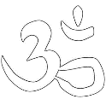  Hindu | Hindus believe in one God who has many different images and names. Hindus show welcome at Raksha Bandhan.
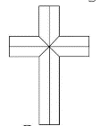  Christian | Christians who believe in God and Jesus. Christians show welcome to babies at a Christening.
Key Facts
- People have different beliefs.
- People celebrate in different ways.
- Christians believe God thinks all people are special.
- I can recall some traditions from a Christening.
- I can recall some other ways that people show they are welcome.

Which groups do you belong to?
How can we help people to feel welcome?
What makes you feel special?
How do you show respect for others?
Who is in your family?
Personal Spirituality Questions
What do you think good behaviour is?

