RE – Creation – Why is the word ‘God’ so important to Christians?
Prior Learning |  | Concepts
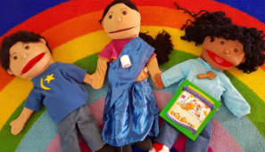  Knowing that people have different beliefs.  The word God is a name.  The special book for Christians is the Bible. |  | Creation – That things can be made (created).
 |  | Belief – That some people have beliefs about how the world was made.
Key Vocabulary |  | Images, icons and maps.
  Religion | A set of beliefs that are important to a group of people. |   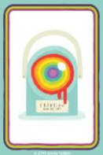  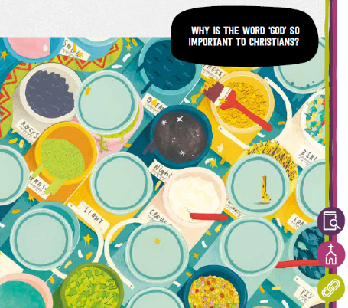  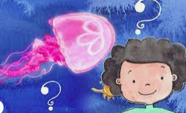  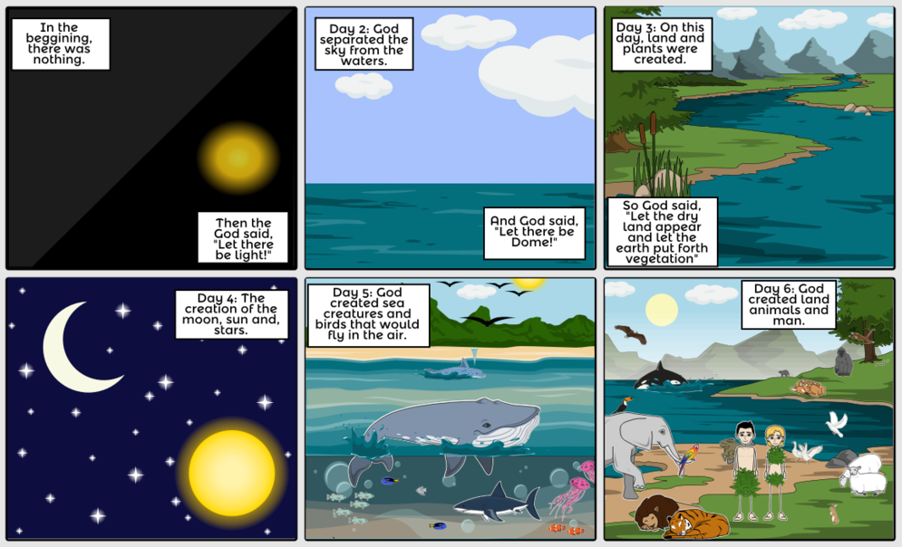
  Bible | The sacred text containing Christian stories and messages.
  Creation | Making something exist.
  Creator | A person who makes things.
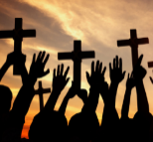  Christians | People who believe in God and Jesus. Christians follow the teaching in the Bible.
Key Facts
- God is an important person to Christians.
- Some Christians believe God created the world.
- God is believed to be a giver of life.
- Christians believe it is important to be kind to all creatures as they are God’s creations.
- The Christian story of Creation is found in the Bible.
- I can help look after the World.
Who do you ask when you need help?
How do you show thankfulness?
Why is it important to be kind to animals?
What do you think is wonderful about the world?
Who are you close to?
Where do you live?
Personal Spirituality Questions
What do you think good behaviour is?

