


Dunchurch Boughton C of E Infant Academy and Nursery

Relationships and Behaviour Policy

Roots to grow. Wings to fly.

Latest policy update: September 2026

This policy should be read in conjunction with:
- The school Child Protection and Safeguarding Policy
- The school Online Safety Policy
- The school Anti-Bullying Policy
- The Multi Academy Trust Suspensions and Exclusions Policy
- The Multi Academy Trust policy – Policy on the Use of Restrictive Interventions including Use of Reasonable Force

And the Department for Education Publications:
- https://assets.publishing.service.gov.uk/media/65ce3721e1bdec001a3221fe/Behaviour_in_schools_-_advice_for_headteachers_and_school_staff_Feb_2024.pdf https://assets.publishing.service.gov.uk/government/uploads/system/uploads/attachment_data/file/1091132/Searching__Screening_and_Confiscation_guidance_July_2022.pdf

Policy Version | Date | Author | Changes
V1 | September 2024 | Suzanne Marson | Initial Issue – new policy
V2 | September 2025 | Suzanne Marson & Hannah Owen | Changes to rewards systems  Added paragraph on leaving the school site  Added Alternative Provision paragraph  Some alterations to sentences made throughout
V3 | 25.6.26 ready for 1.9.26 | Suzanne Marson & Hannah Owen | Policy list changed  Rewording of school day paragraph  Removal of recognition board paragraph - replaced with Dojo Points paragraph  Rewording of rewards section  Rewording of Child on Child Abuse paragraph 1  Removal from classroom paragraph removed  Seclusion paragraph added  Suspension and exclusion paragraph added  Rewording of leaving school site  Meta glasses added to banned items list

Vision and Ethos
Our vision as a Church of England Infant school, deeply rooted in a strong Christian tradition, is to develop happy children with enquiring minds. We support children to develop a spirit of curiosity and respect for themselves, others, and the environment which we live in so that they will have the skills and resilience to thrive in a rapidly changing world.
As part of the Diocese of Coventry Multi Academy Trust, we have a shared vision of ‘Living life in all its fullness’, educating for
- wisdom, knowledge and skills: enabling discipline, confidence and delight in seeking wisdom and knowledge, and developing talents in all areas of life.
- hope and aspiration: enabling healing, repair and renewal, coping wisely when things go wrong, opening horizons and guiding people into ways of fulfilling them.
- community and living well together: a core focus on relationships, participation in communities and the qualities of character that enable people to flourish together.
- dignity and respect: the basic principle of respect for the value and preciousness of each person, treating each person as a unique individual of inherent worth.

Our theologically rooted school vision is based on the Parable of the Mustard Seed, taken from the Gospel of Matthew, reflecting our local rural community and the young age of our children.
Jesus told his followers the Parable of the Mustard Seed:
- A farmer went to plant some seeds in his field.
- He looked at the mustard seeds – they looked very small and not at all important.
- The famer planted the seeds in good soil and took great care to ensure they had everything that they needed.
- Slowly, the little seeds grew into small plants.
- Each day the farmer tended to the plants, and they continued to grow taller and taller still.
- The plants grew into the biggest of all plants, into the size of a tree! The birds came and nested in the branches of the trees.
- The parable teaches us that the smallest things we do can grow into something bigger than we could ever imagine.

The meaning of the parable can be interpreted as below:
- Just like the mustard seeds who appeared small in the beginning, children start their journey at the academy at a young age.
- Dunchurch is the good soil for the children, providing them with the teachings of academic learning, values, learning behaviours, extra-curricular trip and visitors, character and personal development and the word of God.
- Provided with high quality teaching, learning experiences, and a development of character the children begin to develop their roots.
- Through the development of values and learning behaviours, children persevere and become resilient, and begin to learn how they can begin to make a difference in the world. The roots become stronger still, supporting the children to grow.
- As farmers, the adults continuously tend to the children with love, supporting them to develop deep roots that enable them to grow and flourish into all that they can be.
- Just like the branches of the mustard tree that are safe spaces for the birds, our school is a welcoming safe space for all, regardless of background or ability.
- Having developed strong roots to grow, just like the birds in the parable, our children are ready to grow their wings and fly onto their next stage of education, be that their next class or next school.
- Great things come from small beginnings – just like our small children who have grown and flourished in their time at school.

At Dunchurch, we strive to provide the rich soil that enables our children and adults to develop the deep roots to enable them to grow and flourish, from small beginnings comes great things. We aim that everyone feels valued and has respect for themselves, others and the environment in which we live, living together as a school family, just as the birds did within the plant. Within our community, we nurture growth and support everyone to have the courage to face challenge and the resilience to persevere, even when confronted by difficulties. We endeavour to provide abundant opportunities which provide a platform for unique strengths and talents to blossom, providing all with the wings to fly.

This behaviour policy sets out our approach to ensuring high standards of behaviour in and around the school. We aim to achieve this through positive, respectful and consistent interactions with pupils including, when it is necessary, applying sanctions to maintain high standards of behaviour.
We have carefully considered and analysed the impact of this policy to consider possible implications for pupils with protected characteristics, as part of our commitment to meet the Public Sector Equality Duty (PSED) requirement to have due regard to the need to eliminate discrimination, advance equality of opportunity, and foster good relations.
Dunchurch Boughton C of E Infant Academy and Nursery is a Church of England academy and, as such, our relationships and behaviour policy should reflect our Christian vision ‘Roots to grow. Wings to fly.’ If everyone involved with the school builds positive relationships and co-operates and supports each other, then the school can work together in living out its Christian vision and values. Together, we can ensure the school is a positive learning environment where there is self-regulation, effective learning and mutual respect.

This policy is developed to ensure guidance for staff in order to promote positive relationships and behaviour. The procedures and guidance in this document provide a consistent approach across the school and enables children, parents and staff to understand our approaches to the management of behaviour, including rewards and sanctions.

All staff should be made aware of the details of this policy as part of their induction, and it should be applied consistently throughout the school. A review will be held on an annual basis. The Deputy Headteacher (behaviour lead) along with the Headteacher, will monitor the effectiveness of the policy, supported by all stakeholders.

This behaviour policy applies whilst children are in the care of the school, including whilst on school grounds, when taking part in school trips and visits and when taking part in school arranged events such as attending church services. The DfE also state that:
‘The EIA 2006 empowers headteachers to take action to address unacceptable behaviour even when this takes place outside the school premises and when pupils are not under the legal control of the school, but when it is reasonable to do so. In the department’s view, this would include behaviour on school buses, or otherwise on the route to and from school, whether or not the pupils are in school uniform’.

Managing Behaviour and Relationships
One of the most important aspects of children feeling valued, safe and secure in school is the sense of connection with members of staff; the development of strong, positive relationships are vital. For most children this can be achieved by simple acknowledgement of the child and the child having the knowledge that you have them in your mind, care about them as a person and are approachable. At Dunchurch, we take the approach that all behaviour is communication. Thinking of a child as experiencing difficulties encourages you to help them through their distress.
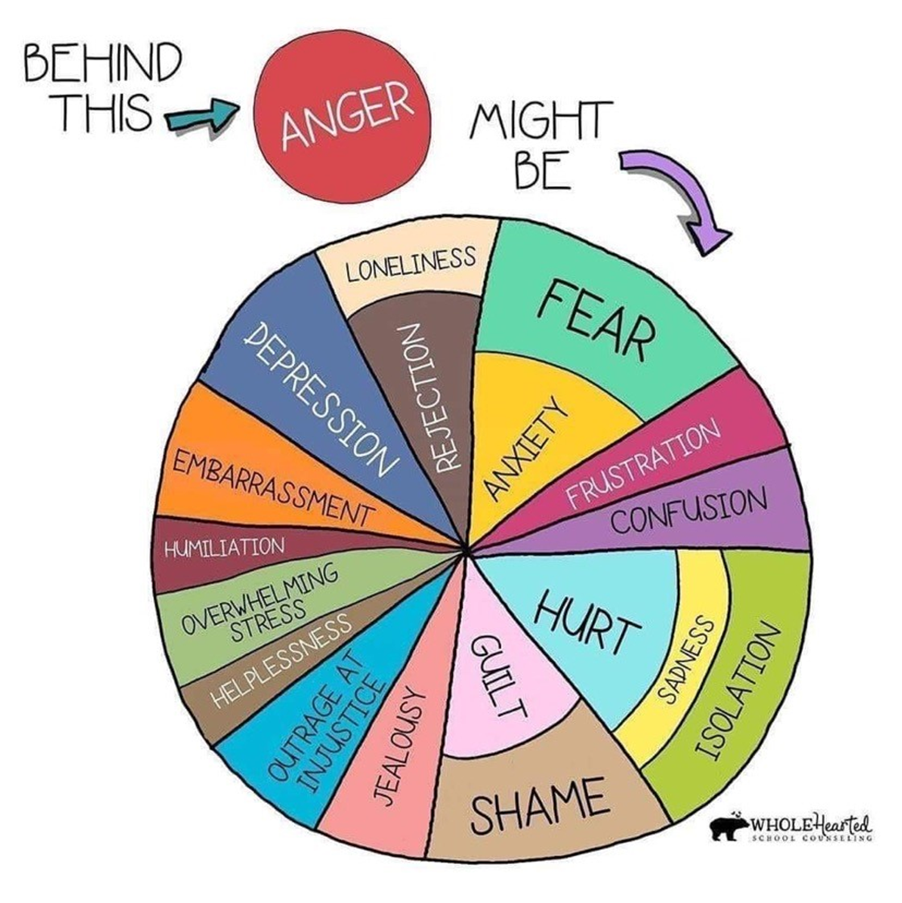
Staff must be fair and consistent with children, taking into account individual needs, and children need to understand that the staff member is in control at all times to enable all children to feel safe. It is also recognised that for some pupils, variance on these procedures will be made in order to meet any specific social, emotional, learning or other Special Educational Need or Disability (SEND) which requires a personalised approach. Support to do this will be sought from the Headteacher / Deputy Headteacher (Special Educational Needs Coordinator) and external agencies if appropriate.

Teachers, Support Staff and Volunteers
Good behaviour is central to a good education and all adults should model the behaviour expected from children themselves. Children will thrive in calm, safe and supportive environments. All adults in school must act in a calm, consistent manner; no adult must ever shout at a child, humiliate them or belittle them. Complete consistency and positive relationships enable children to feel secure and safe. It is the responsibility of the teacher and support staff to ensure that the school rules are enforced in the class, and that children behave in a respectful and responsible manner during lesson time. Staff in our school have high expectations of the children in terms of behaviour, and they strive to ensure that all children work to the best of their ability. There may be times when, at the discretion of the class teacher or support staff, children will be requested to complete work from lessons during play or lunchtimes. This will only occur when there has been sufficient encouragement, support and time allowed during the lesson to complete tasks, but the child has chosen not to undertake the requested work. Children will stay in for a maximum of 5 minutes so that they still have time to eat their lunch / snack, go to the toilet and burn off some energy outside. Employees and volunteers will treat all children in their care with respect and understanding and they will be consistent and calm in their approach. In the first instance, the teacher or support staff will deal with incidents him/herself in the agreed manner, as outlined in subsequent pages.
All employees and volunteers must adhere to the Staff Code of Conduct as required by statutory guidance Keeping Children Safe in Education. It is a core component of the school’s strategy to fulfil its statutory responsibilities to safeguard and promote the welfare of all in school.
The Headteacher, Deputy Headteacher or other senior members of staff must never be used as a threat when discussing behaviour with children; this provides a message to the child that you are unable to deal with their behaviour yourself and, in the long term, may lead to more behavioural difficulties. However, the Headteacher, Deputy Headteacher and senior members of staff will always provide additional support where needed.
The school day for nursery starts at 8:45am. A member of nursery staff greets the children on arrival at the nursery door.
The school days for reception, year one and two starts when the bell is rung on the playground at 8:50am. Teachers and Teaching Assistants should come out onto the playground or to their classroom doors just before the bell is rung in order to greet the children for the start of the day in a positive manner. Children in reception enter via the classroom doors, whilst year one and two line up on the playground before calmly walking into school to start the day with their class teacher.
Meeting the children with a smile and a good morning starts the children’s school day off on a positive footing. Teachers and Teaching Assistants should also go out onto the playground at the end of playtimes and lunchtimes. Children should line up silently in their classes (amazing line ups), before the staff working in each class take their children into school in silence (fantastic walking).

Behavioural expectations
We have three school rules:
- Ready to learn
- Respect (for ourselves, for others, for property and the world in which we live)
- Safe behaviours

These rules are underpinned by the routines of:
- Fantastic walking (walking around school with a quiet or silent voice)
- Amazing line ups (standing sensibly and facing the right way in silence)
- Clean corridors and classrooms (items away and on pegs / in drawers / in boxes)
- Superb sitting (sat cross legged, lips closed, facing the teacher / board and hands in lap, folded or by the side of the child)

Good behaviour in classrooms and around school should include but is not limited to:
- Ready
  - Paying attention to the adult speaking
  - Sitting quietly or in silence, as asked by the teacher
  - Putting effort into work
  - Superb sitting
  - Starting work straight away
  - Demonstrating the school learning behaviours
  - Sitting silently at the lunch table ready for the school prayer
  - Sitting silently ready for the start of Collective Worship
  - Low level disruption of any kind is not tolerated
- Respect
  - Listening when others are speaking; not talking over them or interrupting
  - Looking after the property of children and the school
  - Treating others with friendship and kindness
  - Acting with the school’s Christian Values
  - Telling the truth
  - Celebrating that we are all unique
  - Respecting the views and opinions of others
  - No forms of violence, swearing, name calling or bullying are tolerated
- Safe
  - Following the instructions given by the adult
  - Lining up sensibly – amazing line ups
  - Walking sensibly around school – fantastic walking
  - Clean corridors and classrooms
  - Not putting themselves or others at risk

Staff should ensure there are good routines in place for their classroom and when children are moving around the school. Teachers should explicitly teach the children in their class the school rules and routines, and what this looks like, during the first few days of the academic year. There are also lessons about school and class rules as part of the Jigsaw PSHE programme. These rules, routines and expectations are reinforced through collective worship and interactions with children. All classrooms must display the three school rules and may also choose to display the routines. These should be referred to consistently throughout the day.

It is the expectation of all adults to comment positively when the rules and routines are followed, and equally to challenge children in a supportive way when they are not. The focus should be on positive recognition such as “I like the way that you have …” “Well done for …” “Great effort with…”. Staff should always give a reason for why they are pleased rather than just saying well done. Where it is possible to do so, staff should always catch children doing the right thing first before dealing with less desirable behaviour. This includes at playtimes and lunchtimes.

Dojo Points
All classes across the school have access to Class Dojo and can award the children ‘Dojo points’. Dojo points can be awarded for demonstrating the school rules, routines, Christian values or Learning Behaviours.

Use of Dojo Points:
- Dojo points target learning behaviours, rules and routines (effort, concentration, superb sitting etc.) and not just functional behaviours (e.g. no talking).
- Points are given to recognise children who are demonstrating the desired learning focus / value.
- All adults in the class can add Dojo points, not just the teacher.
- Points are never removed as a sanction. Disruptions are dealt with privately. A different response should be given (see sanctions).
- Emphasise team work; class points will be shared in celebration worship on a Friday.
- Children are praised for effort, not for achievement (linked to growth mindset culture). Dojo points are for everyone and does not exclude the SEND children or those with behavioural needs. .
- Staff use Dojo points consistently to catch children demonstrating the right behaviours.
- The number of Dojo points are displayed for the teacher only, the display is not shared with the whole class. This is to avoid a shame culture and to stop comparisons between children.
- Staff can choose to tell the children they are being rewarded with a Dojo point, or award it in secret e.g. the class hear the ‘ping’ but do not know who it has been awarded to.
- Dojo points are downloaded by class teachers / room leads at the end of each half term to support analysis by the behaviour lead, and then cleared ready for the new half term.

Rewards
Often the most effective reward for work well done or a positive approach to something is verbal praise from an adult. As a school, we seek regular opportunities to praise and thank pupils for their positive actions, including reflecting on how pupils might meet or exceed expectations. Adults should always seek to praise a child who is following the school rules and expectations as a means of promoting good behaviour. Teachers and Teaching Assistants may choose to give out stickers in addition to verbal praise.
Our school learning behaviours develop children’s skills for learning, with rewards linked to when children demonstrate examples of these behaviours.

There are the following weekly awards:

Monday
- Hot Chocolates take place on this day.

Friday
- Learning behaviour of the week – Class teachers select a child from each class who has demonstrated the learning behaviour focus of the half term. Children are presented with a certificate and the teacher / the child shares the nominated piece of work within collective worship.
- A green award is given to the class who has kept the tidiest classroom for the week. The winning class is selected by the caretaker.
- Children can bring in trophies, certificates and other items from home to celebrate their achievements from across the week.
- Hot choc Friday – a child is selected by each class teacher to have hot chocolate with the Headteacher due to going over and above in their demonstration of the school rules, routines and values. These are announced on a Friday morning, with hot chocolate taking place on a Monday.
- A whole class attendance reward is used as a way to promote whole school attendance as part of collective worship.
- Dojo point charts – The whole school Dojo points chart will be discussed as part of a Friday worship. The class with the highest number of points is rewarded with a flag to display. The child with the highest number of points in each class received a Dojo certificate.

The following rewards take place throughout the week:

- Caught doing the right thing – lunchtime supervisors will distribute raffle tickets at lunchtime to children who are following the rules and values of the school. These raffle tickets will be added to a class pot. Every week, a raffle ticket will be pulled out of each class pot by a Midday Supervisor, and that child will receive a certificate at the start of a Friday lunchtime. All raffle tickets will be added to a whole school pot at the end of each week, and every half term, one name will be pulled out from across the school and the child will receive a prize.

- Wow work – across the week, children will be selected by class teachers to show the Headteacher or Deputy Headteacher a piece of work that they are proud of.

Zones of Regulation
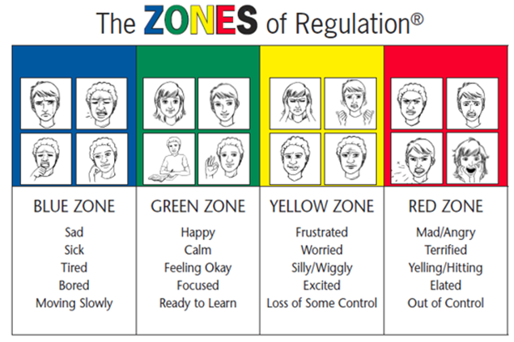
The Zones of Regulation are taught and promoted throughout the school. This supports children to identify their emotions and to develop self-regulation skills. Emotions are separated into four identified zones, supported by the use of words, images and colours. The zones are designed to help children recognise their feelings as well as learn how to use strategies to change or stay in the zone they are in.
In addition to addressing self-regulation, the children develop: an increased vocabulary of emotional terms, skills in reading other people’s facial expressions, perspective about how others see and react to their behaviour, insight into events that trigger their behaviour and calming strategies.

The green zone is used to describe a calm state of alertness. Being in the green zone indicates calm, focused, happy, or ready to learn. This is predominantly the state we want the children to be in.
The yellow zone describes a heightened sense of alertness, with possible feelings of excitement, frustration, anxiety or nervousness Sometimes these emotions are useful, and you still have some control of your actions when you’re in the yellow zone.
The red zone describes an extremely heightened state of intense emotions such as anger, rage, terror or complete devastation and you feel out of control. When a person reaches the red zone, they’re no longer able to control their emotions or reactions.
The blue zone, on the other hand, is used when a person is feeling low states of alertness or arousal such as sadness, illness, tiredness or boredom. You’re still in control, as you are in the yellow zone, but with low energy emotions

Children in school are taught that all emotions are valid and that there aren’t any wrong or bad emotions; everyone feels the spectrum of emotions as times and there is no ‘bad’ zone. Emotion coaching responses are used to verbalise emotions by adults, supporting the children’s understanding.
All classrooms must have the Zones of Regulation on display which are frequently referred to, along with teaching the children the ‘zones’ lessons from the book provided.

Sanctions, reflection and conflict resolution
It is an important part of the role of the school to provide guidance and management to ensure that high standards of behaviour are maintained. The framework below indicates the usual sequence through which staff will progress in the case of children not meeting the behavioural standards expected. However, it is important to note that all staff are able to choose to skip to later stages where they consider the conduct is sufficient to warrant a more serious sanction such as physically hurting another child or adult, swearing or spitting – this will always lead to a restorative conversation. If children have disagreed with each other in situations such as the playground, a restorative conversation should be used as a means of conflict resolution.

Verbal reminder
In the first instance, for low-level misbehaviour, pupils will be issued with a verbal reminder - “Can you make the choice to ..” “It is time to ….” “Remember that we …”

30 second conversation

This is a private word or sanction between the child and adult in the room. This should be short and clear and use emotion coaching responses. Adults should make it clear what the undesirable behaviour is and be clear and assertive. Adults may use terms such as:

I have noticed that you are … do you need some help with …

You have chosen to … (move to the back / wander around the room / be unkind) but you could now …

I can see that you are feeling …. perhaps it would be a good idea to / shall we …

Thank you for …

Do you remember when you (insert desired behaviour here), let’s see if we can do that today

I have heard what you have said, now it is time to …

Your behaviour could be dangerous, you need to … or …

You have a choice to ….. or……. (two choices where you are happy with either option)

Adults should say thank you for listening to signal the end of the conversation, they should move away and leave the child to make a choice, the child may need some take up time for this to happen. Adults should not stand over children waiting for this to happen and should withdraw attention at this point. If children run away when the adult is talking, mimic them or deliberately refuse to listen, adults should continue to give a short explanation to the child and then walk away.

3. Warning
If the behaviour continues, adults should make it clear to the child that they have been issued with a warning and the reason for this “You have continued to …. so now I am giving you a warning. You now have the option to make the right choice. If you continue, you will need to stay with me for five minutes”
4. Five-minute reflection – a restorative conversation
If a warning does not lead to an improvement in behaviour, then staff can issue a time sanction. This will result in 5 minutes of reflection time at playtime, lunchtime or immediately before the end of the day, followed by a restorative conversation. Restorative conversations should also be held where there have been disagreements between children. For information regarding how to hold a restorative conversation, see the restorative practice section below.

As part of a sanction, where property has been broken or a mess has been made, school based community service will take place as part of reflection time, cleaning up the mess made.

The image below should be on display in all classrooms to provide a visual reminder to adults and children.

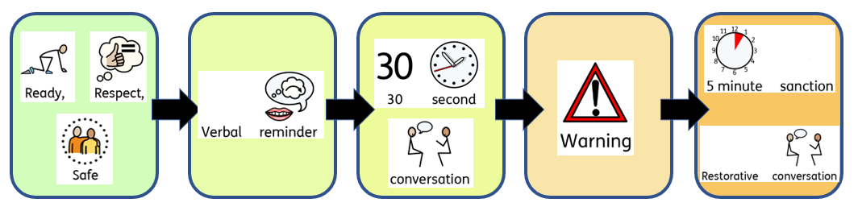

Continuation of behaviour
Following a five-minute sanction and reflection time, if behaviour still persists, or if the children are unable to calm. children should be provided with the opportunity to spend time calming in a sensory area. Senior members of staff should never be used as a threat, this can undermine staff and teach children that staff cannot deal with incidents themselves.

Child on child abuse
When children deliberately hurt another child through actions such as kicking, shaking, biting, hair pulling, hitting, punching or pushing them over, this is child on child abuse. This also includes intimidation and aggressive behaviour. Child on child abuse is never tolerated, and results in an immediate restorative conversation and five minute sanction (reflection time). Any instance of child on child abuse is recorded under this category on CPOMS, and parents informed at the end of the day by the class teacher. Should the behaviour continue to occur outside of age appropriate development, the class teacher or key worker will arrange to meet with parents to discuss their concerns. If the behaviour continues, the Deputy Headteacher / Nursery Manager will become involved and develop a bespoke behaviour plan for the child alongside the class teacher.

We will minimise the risks of child on child abuse by:
• Engaging with the local safeguarding partners in both the prevention and response to child-on-child abuse
• Collecting and responding to pupil voice and listening to the wishes of the pupil that has been harmed in every incident
• Raising awareness of the risks and never normalising these behaviours
• Ensuring that all staff are trained to identify indicators to abuse, and know how to record and respond to these
• Ensuring that policies and procedures are clear and well known
• Not tolerating any form of prejudice
• Ensuring that all children (especially those who identify as LGBTQ) have a trusted/safe adult with whom they feel they can be open with and share their concerns

Seclusion
Seclusion is a non-disciplinary measure which will only be used by staff as a safety measure to prevent others from harm when a pupil is experiencing high levels of emotional or behavioural dysregulation. The place in which a pupil is held will be safe and the pupil will be supervised at all times.

Seclusion will be recorded, reported and analysed in the same way as physical intervention, using the Multi Academy Trust reporting form.

Seclusion should only be used when necessary and once other behavioural strategies in the classroom have been attempted, unless the behaviour is so extreme as to warrant immediate removal.

The length of time should be reasonable and proportionate, and will need to be taken on a case by case basis due to the amount of time that may be needed for different children to become calm. Once the pupil is calm, they should be allowed to leave the area.

Once calm, a restorative conversation must be held, to understand the reasons for the behaviour and to aim to prevent it from occurring again.

If seclusion is used, children are taken to a sensory area. Children are never shut in a room; the door is always left open for the safety of the pupil and staff. However, the door to the sensory corridor may be shut to prevent the pupil from leaving the area.

A senior member of staff, usually the Headteacher or Deputy Headteacher, must always be made aware when seclusion is taking place.

Suspensions and Exclusions
The decision to suspend or exclude a pupil is a serious one and will only be taken in response to
serious or persistent breaches of the academy’s behaviour policy, and if allowing the pupil to
remain in the academy would seriously harm the education or welfare of the pupil or others in the
academy. The decision to suspend a pupil from the academy is made only by the Headteacher (or ‘Acting’ Headteacher if Headteacher is not available. The Deputy Headteacher is designated as ‘Acting’ in this instance). For full information, please see the Multi Academy Trust Suspension and Permanent Exclusion Policy.

Leaving school site
Children are not permitted to leave the school premises during school hours without prior authorisation. Any incident involving a child attempting to leave the boundary of the school premises, or successfully leaving the boundary, will be treated as a serious safeguarding concern. Each case will be considered taking into account the severity of the incident, an understanding of the child’s needs, and any underlying factors such as special educational needs. The school will respond appropriately to ensure the safety and wellbeing of all pupils, while following safeguarding procedures and involving parents. External agencies will be involved where necessary.
Where there are repeated incidents of leaving school site, this will be considered a serious safeguarding breech and action will be taken to try to ensure that the child is safe, including the involvement of external agencies.
Due to the serious safeguarding concern leaving the site poses to both the child and others, this is likely to result in a suspension.

Recording
All necessary logging of behaviour incidents takes place via CPOMS. In the instance that the internet is down, or a staff member cannot access CPOMS for any reason, a form can be completed and handed to any SLT member, which will be scanned in and uploaded to CPOMS as soon as it is possible. Please see the staff CPOMS handbook for examples of these forms.

Behaviour incidents that result in a verbal reminder, 30 second conversation or warning are generally not logged if this is a one off incident that takes place. If a child is reaching these stages more than once in a day, or several times within a week, this should be logged on CPOMS by classroom staff under the correct behaviour category.
If the child reaches the restorative conversation stage of the behaviour strip, this is always logged onto CPOMS so that there is a clear picture and chronology of the behaviour for the child and school. Please see the CPOMS staff guidance for further support.

Any incidents where a child has caused harm to another child or staff member, resulting in first aid, should be recorded as an accident in the accident book. This should also be recorded on CPOMS under the correct category e.g. deliberately hurting another child is recorded as child on child abuse.

All children where behaviour is less than good should have a behaviour plan. The SENDCo/behaviour lead will work alongside classroom staff to put these measures into place.
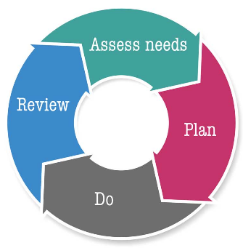
In the case of pupils who present particularly challenging behaviour, it may be appropriate to provide additional support to manage and improve behaviour. This will be bespoke to the child and may include additional steps, individual plans or interventions to prevent incidents of misbehaviour. A graduated response using assess – plan – do – review will be used to determine how successful the approach is for the child.

Informing parents of behaviour incidents
Where a child is frequently not following the rules, or there has been behaviour displayed such as physically hurting or threatening a child or adult or swearing, a conversation will be held with parents by the class teacher. Where a child has physically hurt an adult, the conversation will take place by the class teacher, who will be supported by a member of the Senior Leadership Team. This conversation should be recorded on CPOMS.

Restorative Practice
In line with our Christian ethos, Dunchurch Boughton C of E Infant Academy and Nursery follows a Restorative Justice process to resolve conflict and discuss choices made. The process promotes telling the truth, taking responsibility and acknowledging harm as a response to conflict, creating accountability. It is a valuable tool as it not only allows the child who has made the wrong choice to see the impact of their behaviour, but also allows the impacted individual the opportunity to reflect if they contributed to the conflict in any way by their own behaviour. Both participants are then able to agree their own joint contract of how they are going to treat each other in the future: this gives them a personal stake in the success of the contract. Restorative Conferencing works by staff acting as facilitators who focus attention on the harm that an incident has caused to others; by giving everyone the opportunity to answer the same questions and everyone is given the same opportunity to speak. The controlled equality ensures the process is seen as fair. This encourages the truth and provides a safe environment so that responsibility can be acknowledged, and genuine remorse felt. It is this feeling of remorse drawn out by the process that creates accountability. By looking at what harm has been caused, it brings the participants together to develop a solution. This allows them to take ownership of their solution making it much more likely to succeed.

The 5 R's of Restorative Practice are based on four key features:
  - RELATIONSHIP – building healthy relationships between children and adults
  - RESPECT - listening to other opinions and learning to value them
  - RESPONSIBILTY - taking responsibility for your own actions
  - REPAIR - discussing how to repair harm
  - RE-INTEGRATION - working through a process that solves the problem but allows children to remain in school

During a restorative conversation, children will be asked the following questions, asking the children involved the same questions:

- What happened?
- What were you thinking or feeling?
- How are you feeling now?
- Who has been affected by what you have done?
- In what way have they been affected?
- What can you do differently next time?
- What can you do to make things right?

There are visual prompts displayed in school to support children when carrying out restorative conversations and these should be used as needed by the individuals concerned.

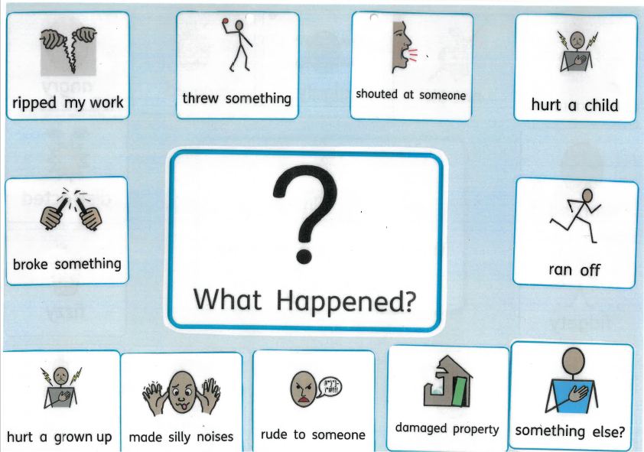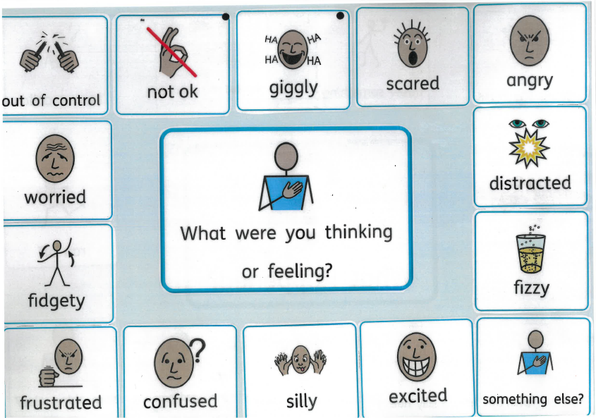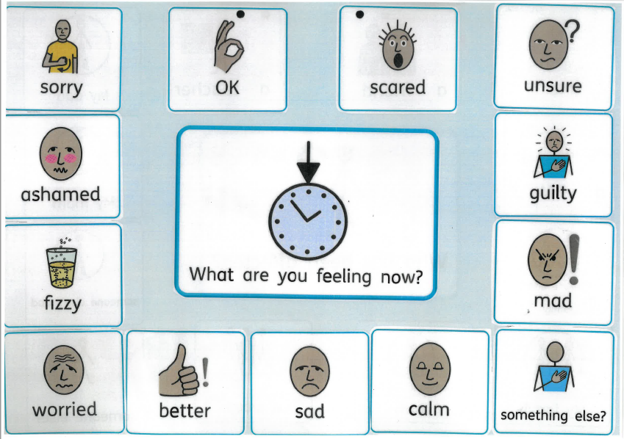
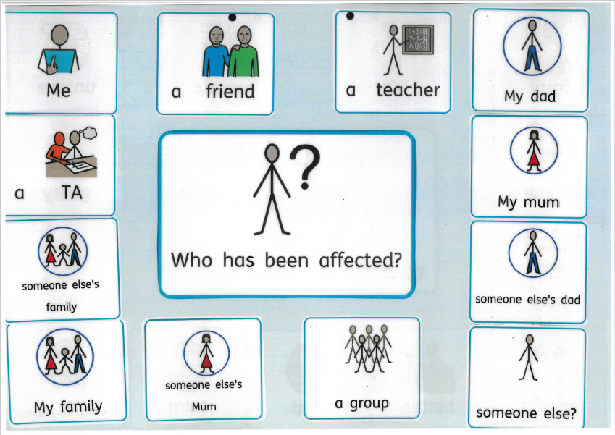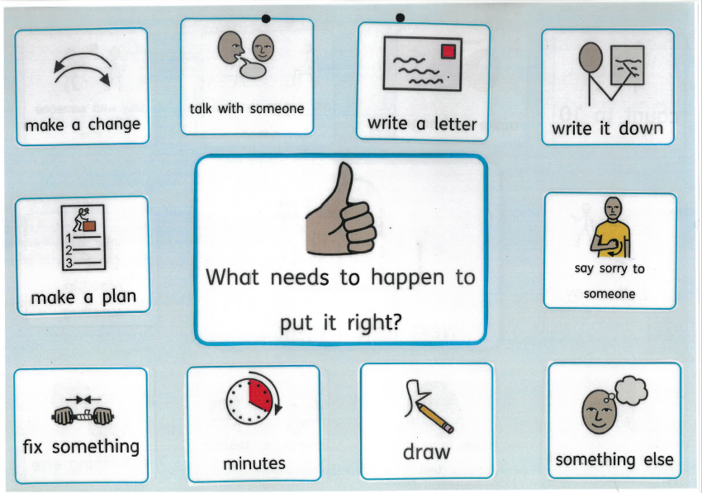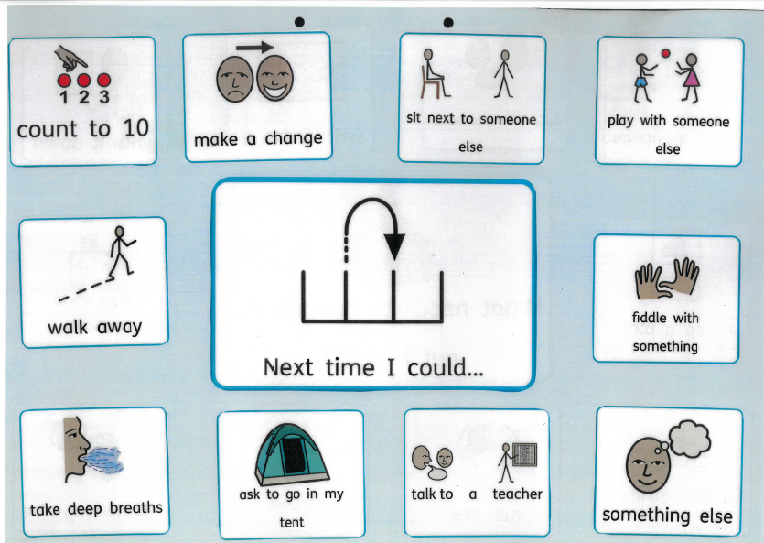

Our Aims for Restorative Justice:
  - To educate children towards self-directed correct behaviour
  - To promote, nurture and protect healthy relationships among members of the community
  - To hold children accountable for the real consequences of wrong doing.

At Dunchurch Boughton C of E Infant Academy and Nursery, we embrace the Church of England’s vision highlighted in the Valuing All God’s Children guidelines, which establish that pupils who bully can be given opportunities to learn and be forgiven. All can go on confidently to serve and make a better, more caring and peaceful world. Pupils are allowed to falter, to get things wrong and try again as they work out how to be in a relationship with themselves and others. A community of compassion is modelled, making this possible.

Consistently challenging Behaviour / Children with Special Educational Needs
Challenging behaviour can take the form of, but is not limited to, verbal abuse, physical abuse, assault, defiant refusal and absconding from the school premises. Where children display consistently challenging behaviour, they will have their own behaviour plan put into place, which will involve a Personal Intervention Plan (PIP) to ensure that all staff are consistent in their approach. We deal with such situations in a positive and calm manner. A de-escalation strategy will be used to diffuse a situation and staff will support children with challenging behaviour within the following framework, using an emotion coaching approach.
  - Use of space, including sensory spaces
  - Safe, calm environments
  - Comfortable environments
  - Diversions and distraction
  - Change of face with another adult
  - Non-threatening facial expressions
  - Low tone, volume, and pace in communication
  - Careful use of words
  - Physical reassurance and prompts
  - Calm stances and posture

Behaviour plans / PIPs are reviewed using the graduated approach on a termly basis, or more frequently if there is a deterioration in behaviour. The SENCo sets up and reviews the plan in conjunction with staff working with the child, and parents. It is recognised that some children with Special Educational Needs may also need their own approach to behaviour, based on their own needs, and that difficulties with Social, Emotional and Mental Health (SEMH) is a form of special need in itself.

Reasonable Force
There may be occasions when a child needs to be physically removed from an area or situation because they are causing a health and safety risk to either themselves or to others. Reasonable force must only be used as a last resort, be reasonable and proportionate, and the child taken to the nearest safest place e.g. into the corridor. The minimum amount of force must be used for the minimum amount of time. It is always preferable to move other children away than to use any form of physical restriction, and if it is possible to do so this must happen. Following any incident of reasonable force, a reporting form must be completed as soon as possible which must be before the end of the school day. This should be handed to the Headteacher or Deputy Headteacher, and the parent/ carer informed by the staff working with the child. A positive handling plan will also be written by the Deputy Headteacher to identify possible triggers, avoidance techniques and agreed holds. This will be completed with the parent / carer’s input. Please see the full Reasonable Force policy.

Parental / Carer Involvement and external agencies
We aim to work in partnership with our parents / carers by informing them of any concerns that we have as early as possible. This may take place in the form of an informal discussion at either the beginning or end of the day, or a more formal meeting when the child has displayed consistent and/or extreme behavioural difficulties.

We also encourage our parents to keep us informed of any behaviour issues they may be experiencing at home and of any traumas that may have occurred e.g. death of a family member or change in family circumstances as these may influence their child’s behaviour. Parents are also encouraged to raise any other behavioural concerns that they may have with us as soon as they can.

Parents have three formal opportunities to find out about their child’s behaviour – a parent’s evening in the Autumn and Spring term and a written report in the Summer term. Where children are on the SEND register, behaviour will also be discussed at termly IEP review meetings. We have an open door policy and parents are welcome to speak to school staff about their child’s behaviour at other times. School staff will also make parents aware if their child is experiencing ongoing difficulties with their behaviour as soon as a problem arises, it will not be left until the next parent’s evening.

Where there are ongoing concerns regarding a child’s behaviour, the support of external agencies may be sought, such as the Specialist Teaching Service or Educational Psychologist. Referrals may be made to the Warwickshire Wellbeing Service or to RISE, with the permission of parents / carers.

Where there are serious concerns about a child’s behaviour, Early Help or Child Protection procedures may be considered appropriate and will be considered on a bespoke basis.

Banned Items and Searching
Children do not need to bring many items with them to school. These should be limited to their coat, book bag, water bottle, lunch box if necessary and, if asked to by their teacher, a show and tell item in nursery.
Children should not bring toys or cards into school with them as they can cause disagreements and may get lost.

The following items are banned and must never be brought into school by children:
- Smart watches that can take pictures, make phone calls, or can connect to the internet
- Mobile phones
- iPads and electronic tablets
- Headphones or ear buds that can access devices and play music (this does not include ear defenders)
- Metaglasses
- Prohibited items and any article specified in regulation. These are outlined in: https://assets.publishing.service.gov.uk/government/uploads/system/uploads/attachment_data/file/1091132/Searching__Screening_and_Confiscation_guidance_July_2022.pdf

- Under common law, school staff have the power to search a pupil in certain circumstances. In this instance, the guidance from the Department of Education would be followed in full: https://assets.publishing.service.gov.uk/government/uploads/system/uploads/attachment_data/file/1091132/Searching__Screening_and_Confiscation_guidance_July_2022.pdf

Electronic devices such as tablets, mobile phones, smart watches and meta glasses are banned items, so there should be no need to search these in school. Should the need arise, the information from page 19 in https://assets.publishing.service.gov.uk/government/uploads/system/uploads/attachment_data/file/1091132/Searching__Screening_and_Confiscation_guidance_July_2022.pdf will be followed.

Confiscation of items
Confiscation of items may take place following a search or following children bringing a banned item into school. Items should be kept in a secure place out of the reach of the child (classroom cupboard or Headteacher’s office) and returned at the end of the day by handing the item to the child’s parents.

Any weapons or items which are evidence of a suspected offence or are likely to be used to commit an offence, must be passed to the police as soon as possible.

Alternative Provision
Alternative Provision may be used in the following circumstances:
- As a planned intervention for behavioural or pastoral reasons
- As a final preventative measure to support children at risk of permanent exclusion

In these circumstances, the underlying ambition is to seek to improve behaviour and maintain learning with the aim to successfully reintegrate children into mainstream lessons.
Where Alternative Provision is used, this will be with guidance and support from the Local Authority. Alternative provision must be suitable to the child’s age, ability and aptitude, and any SEND needs they may have. Information sharing will take place to ensure that the Alternative Provision can support the child’s needs. The provision will deliver a broad and balanced curriculum, and support reintegration. The curriculum delivered may be personalised to meet the child’s needs. Provision should also support the child to overcome their individual barriers to attainment and achievement, giving equal consideration to their pastoral needs, and enabling them to thrive and prosper in the education system. Provision should address a child’s physical or mental health needs as well as personal, social and emotional needs, alongside their educational needs

A reintegration plan will be drawn up with the aim of reintegrating the child back into mainstream school, with weekly reviews taking place with the Deputy Headteacher and parents. External agencies will also have involvement.

The Deputy Headteacher will check in with Alternative Provision as to the child’s attendance and progress on a daily basis. We will follow our safeguarding duties for Alternative Provision as set out in our academy safeguarding policy.

The statutory guidance with regards to Alternative Provision will be followed in full: https://assets.publishing.service.gov.uk/media/67a1ee367da1f1ac64e5fe2c/Arranging_Alternative_Provision_-_A_Guide_for_Local_Authorities_and_Schools.pdf

Behaviour monitoring
Behaviour information is captured daily as incidents occur and is monitored by the Deputy Headteacher on a half termly basis, or more frequently where there are concerns, analysing records for patterns of behaviour and triggers.

Information is collected from the following sources
• behaviour incident data held on CPOMS
- fixed term suspension and permanent exclusion data
• attendance data
• anonymous surveys for staff, pupils, governors and other stakeholders on their perceptions and experiences of the school behaviour culture

Data is analysed at group and individual levels, including by protected characteristics, to ensure policies and procedures are effective, taking action to make improvements if needed.

