RE – Creation – What is special about our World?
Prior Learning |  | Concepts
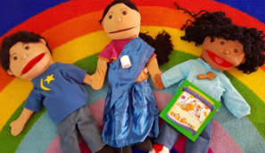  Knowing that people have different beliefs.  Some Christians believe God created the world.  Children can identify some things that they think  are special. |  | Sacred text – Holy books belonging to different religions e.g. Bible, Quran
 |  | Creation – That some people have beliefs about how the world was made.
Key Vocabulary |  | Images, icons and maps.
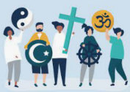  Religion | A set of beliefs that are important to a group of people. | 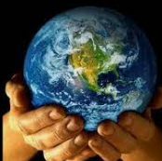  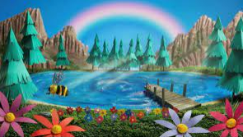  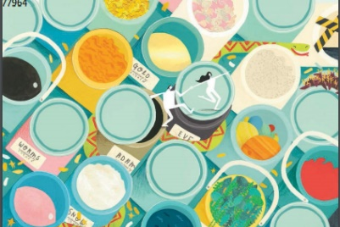  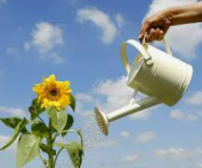  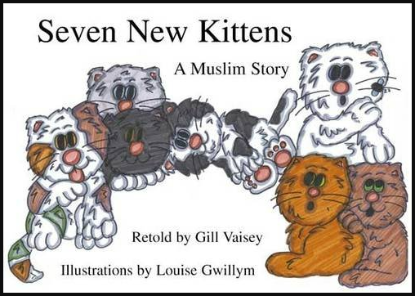
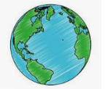  World | The planet Earth and all the people, creatures and plants that live on it.
  Special | Better that ordinary, valued, really great.
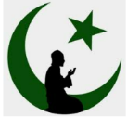  Muslims | People who believe in God (Allah) and follow the teachings of the prophet Muhammad.
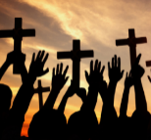  Christians | People who believe in God and Jesus. Christians follow the teaching in the Bible.
Key Facts
- God is an important person to Christians.
- Some Muslims follow the teaching of the prophet Muhammed.
- People with different beliefs think we should look after the world because of what they learn from their religion.
- Many Christians believe it is important to be kind to all creatures as they are God’s creations.
- I can identify what I think is special about the world.
Personal Spirituality Questions
Where do you live?
Who are you close to?
What do you think is wonderful about the world?
Why is it important to be kind to animals?
How do you show thankfulness?
Who helps you make good choices?
What do you think good behaviour is?

