RE Who is Jewish / Muslim, what do they believe?
Prior Learning |  | Concepts
- Talks about people who are special to them, who they admire and why.  - Know about different religious leaders (e.g. Buddha, Jesus, Lord Rama, Prop qualities of good leaders and link this to Muhammad  - Know the story of the Prophet Muhammed and the night of power.  - Ramadan to worship God. What things can/can’t you do during Ramadan? |  | Diversity – A belief in God or Gods and the activities linked with the particular faith, eg prayer or going to a place of worship. Some of the main traditions we study are the Muslim, Jewish, Christian, Buddhist, Sikh and Hindu.
 |  | Understanding – of key religions around the world, demonstrate empathy for those around the world
Key Vocabulary |  | Images, icons and maps.
Leader | Someone who is in charge of a group of others. |   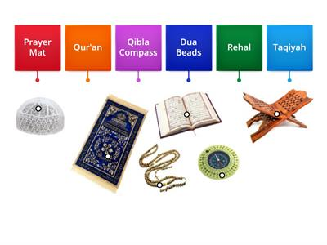  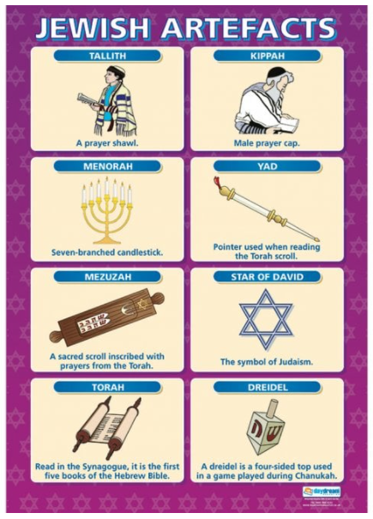  Muslim Artefacts
Prophet Muhammad | An example of an inspiring Muslim leader
Muslim | A tradition that has Allah (God) and Muhammad as their inspiration
Jewish | A tradition based on the idea that there is one God
Tradition | A way of life
Inspirational | Ideas and actions that others want to follow, do
Key Facts
Jesus was very important to Christians because they believe him to be God on Earth.
Christians believe it is important to give to all people at Christmas, especially those who are poor or less fortunate. Not just because it is a good this to do, but because it is what Jesus would have done.
What do you think good behaviour is?

