RE - Salvation
Prior Learning |  | Concepts
- Collect responses of why pupils think Easter is important to Christians.  - Set up an Easter labyrinth for pupils.  - Essential parts of the story to be included in the labyrinth for Year 1 are: 1) The entry into Jerusalem; 2) Jesus’ betrayal and arrest at the Mount of Olives; 3) Jesus’ crucifixion; 4) The empty tomb; Jesus’ appearance to Mary Magdalene and the disciples. Children to stop at each point to discuss and reflect on their thoughts and feelings.  - Simply order events by threading images onto string. What do we think id the most important part of the Easter story and why? |  | Jesus came to build a bridge back to God
 |  | Christians believe in forgiveness and that God will forgive them for their sins
 |  | Lent is the time Christians remember Jesus fasting in the desert and being tempted.
Key Vocabulary |  | Images, icons and maps.
Salvation | Saving a person from sin | 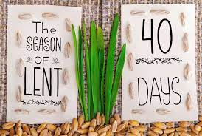  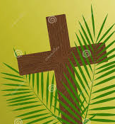  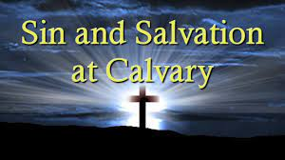  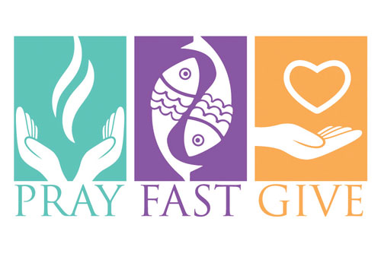
Forgiveness | When you are upset or cross with someone but you then accept their apology and you are no longer upset or cross with them.
Fasting | Giving up something e.g food
Lent | Time of fasting, prayer and almsgiving remembering Jesus fasting in the desert
Easter | Celebration of Jesus rising from the dead
Humility | being modest, respectful and putting others before yourself. It is not calling attention to yourself or being rude
Trial | the act of hearing a case in court to decide whether or not a person has broken a particular law.
Sin | Not following religious values
Key Facts
Jesus was very important to Christians because they believe him to be God on Earth.
Christians believe it is important to give to all people during Lent, especially those who are poor or less fortunate. Not just because it is a good this to do, but because it is what Jesus would have done.
What do you think good behaviour is?

