RE – The Good News / Gospel
Prior Learning |  | Concepts
- Recall that Christians believe Jesus brings ‘Good News’  - Jesus had 12 special friends, known as disciples.  - Jesus made this promise to give his disciples peace in their hearts |  | Christians were feeling lonely or unloved, could turn to God for comfort
 |  | Christians love God and their neighbour by following the good news that Jesus brought
Key Vocabulary |  | Images, icons and maps.
Friendship | A friend is a person that someone likes or knows | 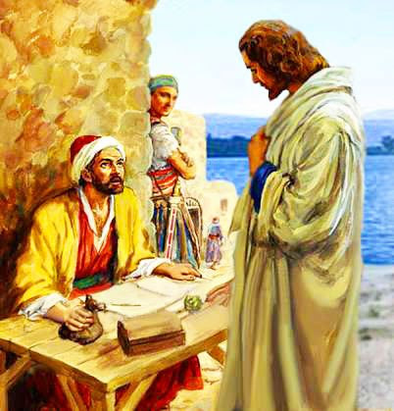  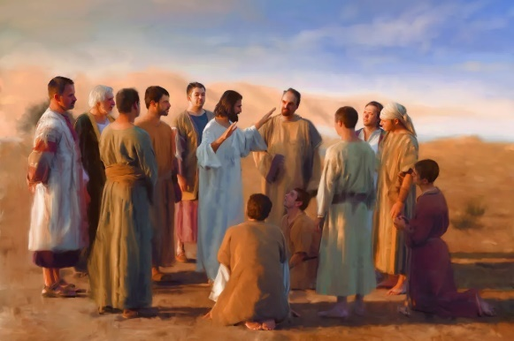  Jesus had 12 special friends to help him spread the Good News  Jesus was a friend to the friendless: Matthew 9:9-13
Forgiveness | Forgiveness simply means you're letting go of feelings of resentment and vengeance
Peace | a state of freedom from war or conflict.
Disciple | The word gospel means “good news,” and gospel songs often praise God or Jesus. Many gospel songs also describe struggles and hard times.
Good News | When we believe that Jesus is God’s Son and that he died and came back to life to rescue US–we get to be part of God’s family forever!
Key Facts
Jesus died on the cross for our salvation
Jesus and his disciples spread the good news
The ‘good news’ is written in the Gospels in the bible
Jesus had 12 special friends to help him spread the good news
What do you think good behaviour is?

