DESIGN & TECHNOLOGY/ EXPRESSIVE ARTS & DESIGN

CREATING WITH MATERIALS
Purpose of Study:
Design and technology is an inspiring, rigorous and practical subject. Using creativity and imagination, pupils design and make products that solve real and relevant problems within a variety of contexts, considering their own and others’ needs, wants and values. They acquire a broad range of subject knowledge and draw on disciplines such as mathematics, science, engineering, computing and art. Pupils learn how to take risks, becoming resourceful, innovative, enterprising and capable citizens. Through the evaluation of past and present design and technology, they develop a critical understanding of its impact on daily life and the wider world. High-quality design and technology education makes an essential contribution to the creativity, culture, wealth and well-being of the nation.
The national curriculum for design and technology aims to ensure that all pupils:
- develop the creative, technical and practical expertise needed to perform everyday tasks confidently and to participate successfully in an increasingly technological world
- build and apply a repertoire of knowledge, understanding and skills in order to design and make high-quality prototypes and products for a wide range of users critique, evaluate and test their ideas and products and the work of others § understand and apply the principles of nutrition and learn how to cook.
EYFS Learning goals:

Creating with Materials:

- Safely use and explore a variety of materials, tools and techniques,
experimenting with colour, design, texture, form and function.

- Share their creations, explaining the process they have used.

- Make use of props and materials when role playing characters in narratives and stories.
KS1 Pupils should be taught:

Design
- design purposeful, functional, appealing products for themselves and other users based on design criteria
- generate, develop, model and communicate their ideas through talking, drawing, templates, mock-ups and, where appropriate, information and communication technology
Make
- select from and use a range of tools and equipment to perform practical tasks [for example, cutting, shaping, joining and finishing]
- select from and use a wide range of materials and components, including construction materials, textiles and ingredients, according to their characteristics
Evaluate
- explore and evaluate a range of existing products evaluate their ideas and products against design criteria
- Technical knowledge
- build structures, exploring how they can be made stronger, stiffer and more stable
- explore and use mechanisms [for example, levers, sliders, wheels and axles], in their products
Cooking and Nutrition
- use the basic principles of a healthy and varied diet to prepare dishes understand where food comes from.

Intent
Across the Dunchurch Federation the intent of the DT Curriculum is to provide plenty of opportunities for the children to learn, apply and strengthen essential skills required in the designing, making and evaluating of an effective product for a given purpose. Using creativity and imagination, pupils design and make products that solve real and relevant problems within a variety of contexts, considering their own and others’ needs, wants and values. Pupils learn how to take risks, becoming resourceful, innovative and enterprising.

Implementation
To ensure high standards of teaching and learning in design and technology, we implement a curriculum that is progressive throughout the whole school. Design and technology is generally taught as part of a half-termly topic, focusing on knowledge and skills stated in the National Curriculum. The teaching of DT should enable all children to gain ‘real-life’ experiences. Teachers plan lessons for their class using our progression of knowledge and skills documents. The progression document ensures the curriculum is covered and the skills/knowledge taught is progressive from year group to year group.

Impact
The high-quality teaching of DT at Dunchurch will enable learners to build a strong range of core skills as they progress through the school that will give them the opportunity to become resourceful, innovative, enterprising and capable citizens. All children will feel empowered to design and create a range of products as well as applying practical expertise to enable them to participate successfully in an increasingly technological world. Children will evaluate work by other designers and consider how resources may be adapted to suit the needs of others. They will learn to see the value of design in a variety of contexts and the scope of art to build towards different careers in the future.

Skills and Progression

 | Rising 3’s | Pre-school | Reception | Year 1 | Year 2
Key Concept:  Developing, planning and communicating ideas. | ELG: To share their creations, explaining the processes they have used.  Imitates everyday actions and events from their own family/cultural background when using a range of construction materials / objects in the environment.  Use a range of tools and construction materials in the environment, developing their ideas about how to use them and what to make, with a large range of items freely available in continuous provision e.g. scissors, hole punches, hammers, string, tape, masking tape, glue, boxes, tissue paper, paint, sequins, feathers, pipe cleaners, paper clips, fasteners, straws, felt, beads, large paper, long strips of wallpaper, natural materials from outside etc. | ELG: To share their creations, explaining the processes they have used.  Constructs with a purpose in mind e.g. uses paper and tape to make a bag in play.  Use a range of tools and construction materials in the environment, developing their ideas about how to use them and what to make, with a large range of items freely available in continuous provision e.g. scissors, hole punches, hammers, string, tape, masking tape, glue, boxes, tissue paper, paint, sequins, feathers, pipe cleaners, paper clips, fasteners, straws, felt, beads, large paper, long strips of wallpaper, natural materials from outside etc. | ELG: To share their creations, explaining the processes they have used.  Explains what they are making with a purpose in mind, and suggests what materials they are going to use.  Use what they have learnt about media and materials in original ways, thinking about uses and purposes.  Select and name the tools needed to work the materials e.g. scissors for paper, hammer for nails.  Explore ideas by rearranging materials.  Discuss their work as it progresses. | Explains what they are making with a purpose in mind, and suggests what materials they are going to use.  Begin to understand the development of existing products; what they are for, how they work, the materials used.  Start to suggest ideas and explain what they are going to do.  Understand how to identify a target group for what they intend to design and make based on a basic criteria.  Begin to develop their ideas through talk and drawings.  Make templates and mock ups of their ideas on paper or using IT. | Draw on their own experiences and research conducted to help generate ideas.  Begin to develop their design ideas through discussion, observation, drawing and modelling.  Identify a purpose for what they intend to design and make.  Understand how to identify a target group for what they intend to design and make based on a design criteria.  Develop their ideas through talk and drawings, and label parts and materials.  Make templates and mock ups of their ideas in card and paper or using ICT.

 | Rising 3’s | Pre-school | Reception | Year 1 | Year 2
Key Concept:  Working with tools, equipment, materials and components / being imaginative and expressive | Explore a range of mechanical equipment in play e.g. cogs, wind-up toys and toys with pulleys.  To build structures with blocks, clay, wood and card, making simple models that express their ideas.  Develop manipulation and control by making toys work by pressing buttons of lifting flaps to achieve effects, such as sound and movements.  To use one handed tools and equipment e.g. makes snips in paper.  To explore natural materials inside and outside, representing their ideas and interests. | To verbalise intentions prior to construction using a wide range of materials freely available in play.  To handle tools, objects, construction and malleable materials safely.  To select tools and techniques needed to shape, assemble and join materials they are using in play.  Begin to use scissors to cut straight and curved edges.  To understand that different media can be combined to create new effects.  Thread large beads onto a string. | To verbalise intentions, making an object for a purpose.  Create their design using basic techniques of sticking, folding, scrunching and bending.  Use different techniques for joining materials e.g. explores how to use different types of tapes or glues.  Use scissors to cut straight and curved edges.  Children safely use and explore a variety of materials, tools and techniques with colour, design, texture, form and function.  Thread small beads onto a thin piece of thread. | Begin to make their design using appropriate techniques – cut, fold, stick, scrunch, bend, sew, glue, fringe, curl, link, fasten, hole punch, staple etc.  Begin to build structures exploring how they can be made stronger.  Explore and use mechanisms (levers, sliders) in their products.  Measure out, cut, join and shape a range of materials.  Assemble, join and combine materials and components together using different methods (gluing, taping, clipping, tying and pinning including split pins).  Demonstrate how to cut, shape and join fabric to make a simple product. (forwards stitch) | Begin to select tools and materials to apply knowledge of techniques with increasing control, using the correct vocabulary to name and describe them.  Build structures, exploring how they can be made more stable.  Explore and use mechanisms (wheels and axels) in their products.  Measure out, cut, join and shape a range of materials with increasing accuracy.  Assemble, join and combine materials and components together using different methods with increasing accuracy (gluing, taping, clipping, tying and pinning including split pins).  Demonstrate how to cut, shape and join fabric to make a simple product. (running stitch)

 | Rising 3’s | Pre-school | Reception | Year 1 | Year 2
Key Concept:  Evaluating processes and products. | Demonstrates pride in their creations. | To say what has worked well with their constructions. | Say what they like and do not like about items they have made and attempt to say why.  Begin to talk about their designs as they develop and identify good and bad points.  Start to talk about changes made during the making process.  Discuss how closely their finished products meet their design criteria.  Share processes used to create their product. | To talk about their ideas, saying what they like and dislike about them, giving reasons for these opinions.  Begin to evaluate their products as they are developed, identifying strengths and possible changes they might make.  Start to evaluate their product by discussing how well it works in relation to the purpose (design criteria).  When looking at existing products explain what they like and dislike about products and why. | With confidence talk about the strengths and weakness of their ideas linking their reasons for these opinions to the design criteria.  To evaluate their products as they are developed, identifying strengths and begin to make changes as appropriate.  Evaluate their work against their design criteria.  Look at a range of existing products explain what they like and dislike about products and why.

 | Rising 3’s | Pre-school | Reception | Year 1 | Year 2
Key Concept:  Food and Nutrition | With support, explore familiar food products – fruit and vegetables. Taste, touch and smell.  With support wash and dry hands.  Begin to notice that some food is grown and take part in class growing activities. | Sort familiar foods with support as needed e.g. these are all fruits.  Manages hand washing independently.  Stir, spread, knead and shape a range of food and ingredients with support.  With support, prepare dishes safely and hygienically involving a heat source. | Explore familiar food products – fruit and vegetables. Taste, touch, smell and observe similarities and differences.  Stir, spread, knead and shape a range of food and ingredients.  Begin to practise some hygiene measure to keep healthy and safe – thorough hand washing and wiping of surfaces.  Start to think about the need for a variety of foods in a diet.  Sort food items into health and unhealthy foods.  Begin to understand that eating well contributes to good health.  Begin to understand that all food comes from plants or animals.  Begin to understand that food has to be farmed, grown or caught. | Observe basic food hygiene procedures – washing hands, cleaning surfaces and washing fruit/veg before preparing/cooking.  Know that all food comes from plants or animals.  Know that food has to be farmed, grown or caught.  Prepare dishes safely and hygienically without a heat source.  Start to understand the concept of ‘The Eat well plate’ and sort basic foods into food groups | Know how to use techniques such as cutting, peeling and grating.  Observe basic food hygiene procedures – washing hands, cleaning surfaces and washing before preparing/cooking.  Know that all food comes from plants or animals and has to be reared, grown or caught.  Prepare dishes safely and hygienically with a heat source  Know that food has to be reared or grown (in the UK or in other countries) or caught.  Understand how to name and sort a range of foods into the five groups in ‘The Eat well plate’ and that it is recommended that 5 portions of fruits and vegetables are eaten daily.

Project focuses:

Reception | Year 1 | Year 2
Input delivered and through continuous provision:  -Lanterns  -Shoes  -Chairs  -Bridges (linked to Billy Goats Gruff)  -Hats  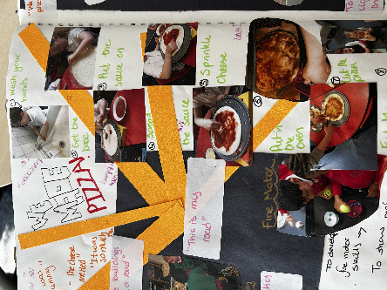  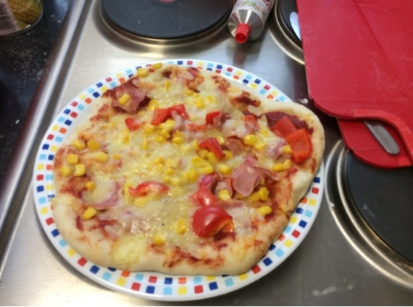  Pizza  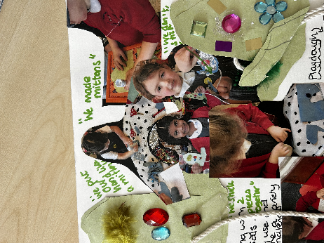  Mittens  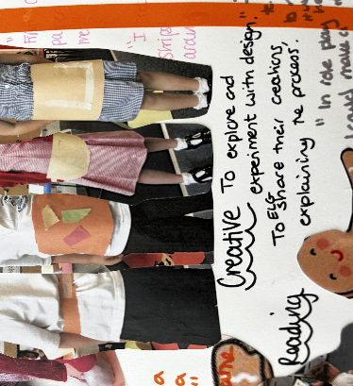  Aprons | 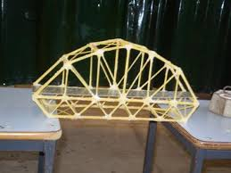  Bridges  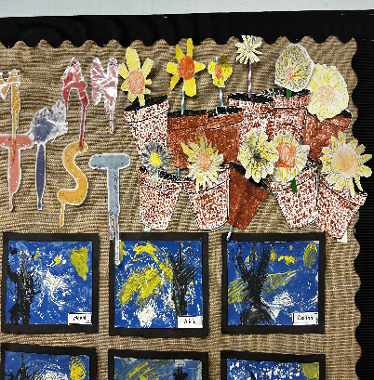  Levers and sliders  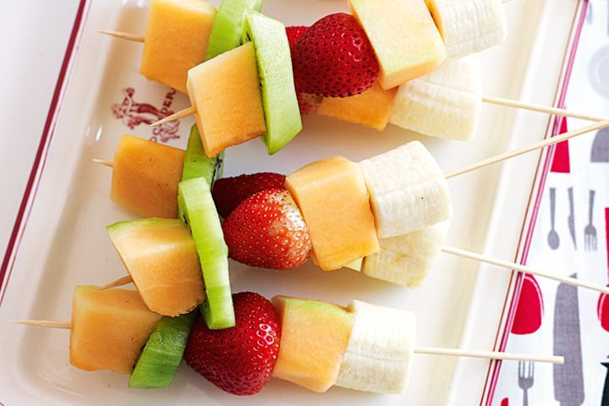  Fruit skewers | 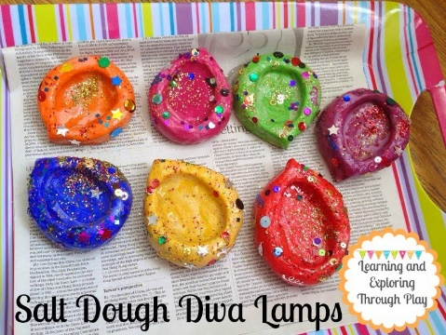  Diva lamps  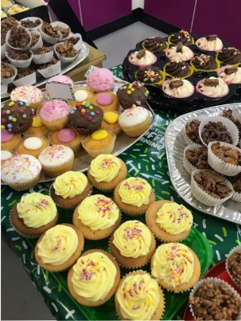  Cakes (linked to Macmillan)  Sewing (running stitch)- linked to Mother’s Day  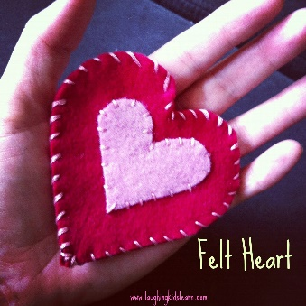  Moving vehicles (wheels and axels)  

